


Project Navodaya

ABAP Technical Specification

Document Information

Document Number
Title | RAP Application for YRGR032
Document Purpose | Optimization of report YRGR032
Key Words
Document Status | Final
Contact for Enquiries | SARFRAZ

Document Change Control :
Release | Description | Created by | Date | Reviewed by | Date | Approved by | Date
01 | RAP Application for YRGR032 | SARFRAZ | 17-01-2025

Header
Area (R/3Module): | GMS |  |  |  |  | Date: |  | 17-01-2025
Requested by: | GAIL GMS team
Title: | RAP Application for YRGR032
Short description: | Optimization of report YRGR032
Functional Developer: | Sathish Minakshi Sundaram (SAP) |  |  |  |  |  | Phone: | +91
Technical Developer: | Sayyad Sarfraz Ali |  |  |  |  |  | Phone: | +91 8827833896
Program name:
Type: | Change Request Development Request(Creation) Rework
Program type: (select the check box) | Conversion Batch Interface Online Interface Report  Form Enhancement Extension Dialog  Modification Unknown Others BAPI  ALE/ IDOC Application Development
Priority: | Very High High Medium Low
Complexity: | Very High High Medium Low
Specify known SAP functionality: |  | <Specify the related SAP transactions>
Cross Reference Documentation:
Only for Interfaces:  Type of interface:  Direction of interface:  Frequency: |  |  |  | Real-Time Batch  Inbound Outbound Both  Daily Weekly Monthly  Biweekly Other:
Only for Reports:  1. The report will be created via:  2. Requested characteristics: |  |  | Standard Report  Report Painter Report Writer ABAP Query  ABAP Program Info System  Drill-down Pushbuttons Sort  Entry files Others: _____________________
Generic question:  1. Impact of not creating the program: |  |  | legal requirements will not be fulfilled  lack of information required for the business  lose functionality compared to the old system  others: could have duplicate data entered into the system_
Development labor estimate:
Are there any alternatives in the standard system: |  |  |  |  | Yes No
Describe the alternative found:
Reason why this alternative was not acceptable: |  |  |  |  | Performance problems Complexity  Others: The transaction to initiate

Technical Specification
3.1. Technical Report Created:

Root CDS: YRGR032_ANALYTIC
Entity Set: YRGR032_ANALYTIC
ODATA Service: YRGR032_ANALYTIC_CDS

Development Overview

Sr. No | Program Name | Transaction Code | Transport Request No | Dependency/ TR Sequence
1 | YRGR011_ACTUAL_VS_ME_DATA | YRGR032 | SBRK902891

Development Details

Code

Screen:

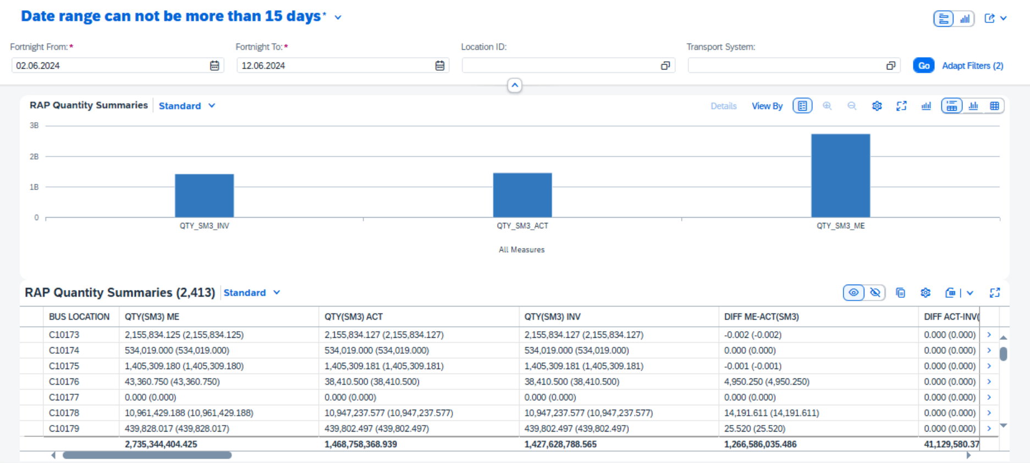

Logic:

- CDS: YRGR032_LIPSO2
This CDS view fetches the Delivery Number and MAX Additional Oil Quantity from table LIPSO2 for rows where Unit of Measurement is in [SM3, MCN, MBG, MBN] grouped by Delivery Number and Unit of Measurement. There will be four columns for Additional Oil Quantity based on the value of Unit of Measurement.
- CDS: YRGR032_VBFA
This CDS view fetches Preceding sales and distribution document from table VBFA selecting matching rows from YRGR032_lipso2 CDS view based on Preceding sales and distribution document and Delivery Number, Adding Additional Oil Quantity columns where Document Category of Subsequent Document is equal to ‘M’. group by is used on Preceding sales and distribution document to avoid duplicate entries.
- CDS: YRGR032_QTY2
This CDS view fetches Delivery Number, Ship-to Party, and Actual Goods Movement Date from table LIKP joining CDS YRGR032_VBFA based on Preceding sales and distribution document and Delivery Number from LIKP, where Delivery Type in [ZING1, ZING2, ZNT3, NLCC]. Group by on Ship-to Party, Delivery Number, and Actual Goods Movement Date is used to avoid duplicate entries.
- CDS: YRGR032_QTY
This CDS view fetches Delivery Number, Ship-to Party, and Actual Goods Movement Date from table LIKP joining CDS view YRGR032_LIPSO2 based on Delivery Number, where Delivery Type in [ZING1, ZING2, ZNT3, NLCC]. Group by on Ship-to Party, Actual Goods Movement Date, and Delivery Number is used to avoid duplicate entries.
- CDS: YRGR032_KUNNR
This CDS view fetches Location ID, Customer Number, MAX (Transport system) from table OIJRRA, MAX (Additional Oil Quantity columns) from CDS view YRGR032_QTY, MAX(Additional Oil Quantity columns) from CDS view YRGR032_QTY2 and Actual Goods Movement Date, Delivery Number from table LIKP by joining table LIKP based on Delivery Number and CDS view YRGR032_QTY and YRGR032_QTY2 based on Ship-to Party, LIKP-Delivery Number, and LIKP-Actual Goods Movement Date where Deletion Indicator not equal to ‘X’. Group by Location ID, Customer Number, Delivery Number, and Actual Goods Movement Date.
- CDS: YRGR032_YRAX_MAX
This CDS view fetches Location Partner, Location ID, UTC Time Stamp, and Date from table YRXA_CMDATA where Date should be grater than or equal to parameter p_sdate and Date should be lesser than or equal to parameter p_edate. Group by on Location ID, Date, Location Partner to avoid duplicate entries.
- CDS: YRGR032_KUNNR_M
This CDS view fetches Location ID, MAX (Transport system), and Sum of Additional Oil Quantity columns from CDS view YRGR032_KUNNR where Actual Goods Movement Date should be greater or equal to parameter p_sdate and lesser than or equal to parameter p_edate. Group by on Location ID is used to avoid duplicate values.
- CDS: YRGR032_YRXA_CMDATA
This CDS view fetches Location ID, Sum of Cumulative Volume, Sum of ‘Cumulative Volume * Average NCV’ when Average NCV is not null and converts to 1000000 fltp, Sum of ‘Cumulative Volume * Average GCV’ when Average GCV is not null, Sum of ‘Cumulative Volume * Average NCV’ when Average NCV is not null and converts to cast(1000000.0 as abap.fltp) * cast( 3.968254 as abap.fltp ) from CDS view yrgr032_yrax_max and also joining table yrxa_cmdata Location Partner, Location ID, UTC Time Stamp, and Date. Group by on Location Id is used to avoid duplicate values.

- CDS: YRGR032_LAYER
This CDS view fetches Location ID from table OIJLOC, MAX (Transport system), MAX (Additional Oil Quantity columns) from CDS view YRGR032_KUNNR_M and MAX (Additional Oil Quantity columns) from CDS view YRGR032_YRXA_CMDATA by joining YRGR032_KUNNR_M and YRGR032_YRXA_CMDATA CDS view where OIJLOC -Deletion Indicator not equal to ‘X’. Group by Location ID is used to avoid duplicate values.
- CDS: YSH_TSYST
This CDS view fetches Transport system from table OIJTS.
- CDS: YSH_LOCID
This CDS view fetches Location ID, Location name from table OIJLOC.
- CDS: YRGR032_FINAL
This CDS view fetches Location ID, Transport system, Additional Oil Quantity columns from YRGR032_LAYER CDS view.
- CDS: YRGR032_CUBE
This CDS view fetches Location ID, Transport System, Additional Oil Quantity columns from YRGR032_FINAL CDS view. CDS view YSH_LOCID and YSH_TSYST CDS view is associated based on Location ID and Transport System respectively.
- Root CDS: YRGR032_ANALYTIC
This CDS view fetches Location ID, Transport System, Additional Oil Quantity columns from YRGR032_CUBE CDS view.
- Metadata:
Once the data is fetched from the CDS, a metadata is created to define the UI of the fiori app.
- Service Definition Exposure:
Once the metadata is defined for the CDS view entity elements, it is exposed through a service definition. This step makes the data accessible for external systems to consume.
- Service Binding and Maintenance:
The service definition is bound and maintained. This ensures that the service is available to the desired applications and users.
- Fiori Tile Creation and Role Assignment
A Fiori tile is created to display the data exposed by the service. Additionally, roles are assigned to ensure that only authorized users can access and view this tile.

Table Creation
N/A

Security /Authorization
N/A

User Exit
N/A

Transaction / Batch Job that will access enhancement
N/A

Anticipated performance Issues (if any)
N/A

Registration
N/A

Assumptions/ Notes

Unit Test Case
Screenshot for testing

- Report Screen:

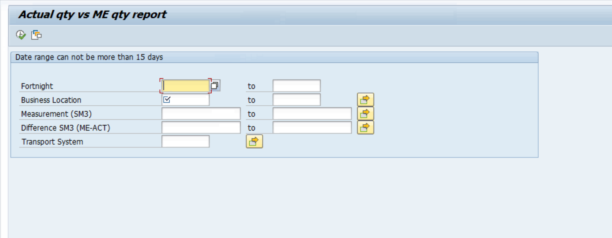
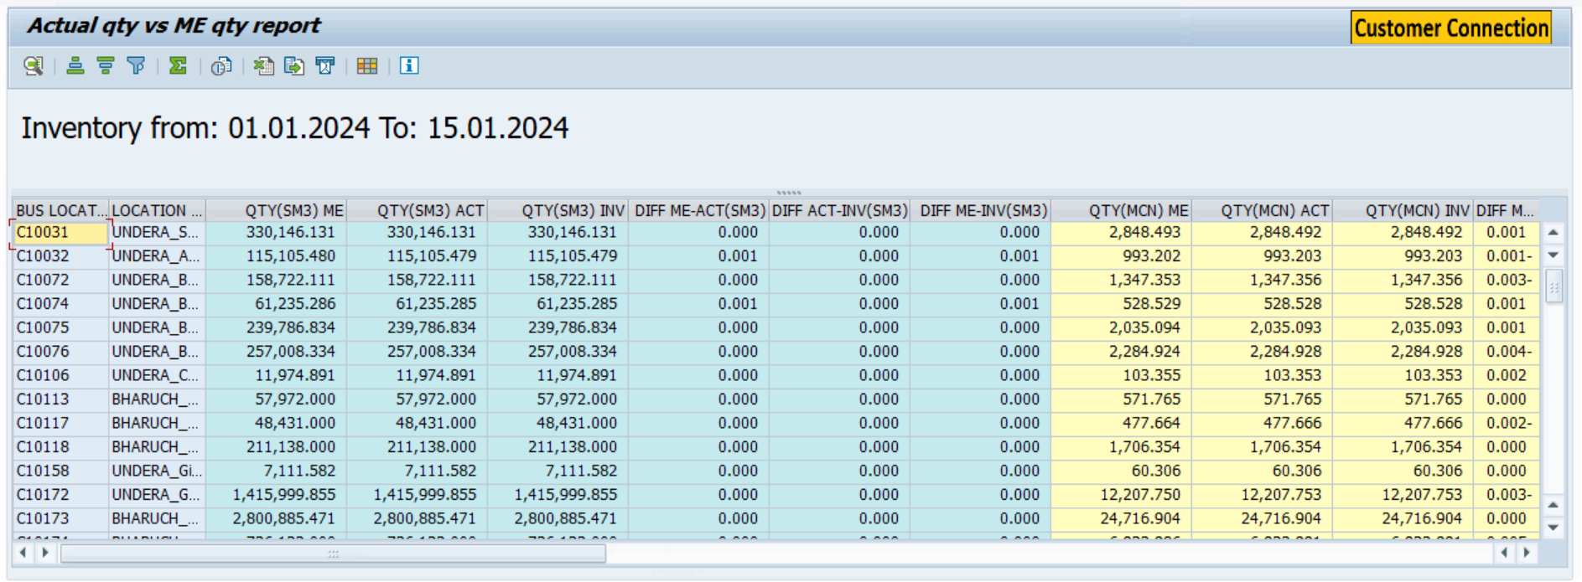

- Fiori Screen:

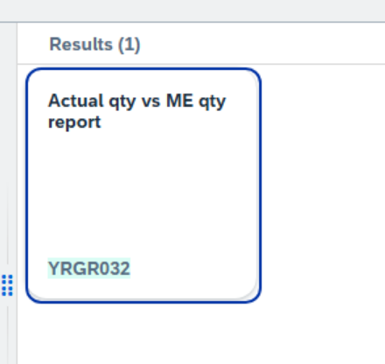



Technical Spec Original Sign Off:

Names and Signatures:

_____________SARFRAZ_______________________________ Date: ___16/06/2025________

____________________________________________________ Date: _____________

____________________________________________________ Date: _____________

____________________________________________________ Date: _____________

Modifications
< Description of Modification if any>
<Support document of the modification like screen shot of email received>

